1.Perform basic Image Handling and processing operations on the image is to read an image in python and Convert an Image to Gray-scale.
AIM
To perform basic image handling and processing operations by reading an image in Python and converting the image into grayscale using OpenCV.
PROCEDURE
- Install the OpenCV library using pip install opencv-python.
- Import the OpenCV library using import cv2.
- Read the input image using cv2.imread().
- Convert the color image into grayscale using cv2.cvtColor().
- Display the original image using cv2.imshow().
- Display the grayscale image using cv2.imshow().
- Use cv2.waitKey(0) to wait for a key press.
- Close all image windows using cv2.destroyAllWindows().
PROGRAM
import cv2

# Read the image
image = cv2.imread("photo.jpg")

# Convert image to grayscale
gray = cv2.cvtColor(image, cv2.COLOR_BGR2GRAY)

# Display original image
cv2.imshow("Original Image", image)

# Display grayscale image
cv2.imshow("Gray Image", gray)

# Wait for key press
cv2.waitKey(0)

# Close all windows
cv2.destroyAllWindows()
INPUT
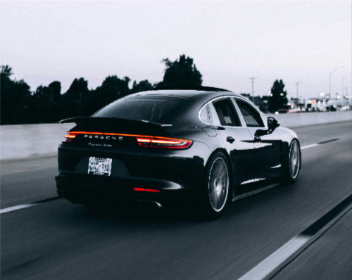
OUTPUT
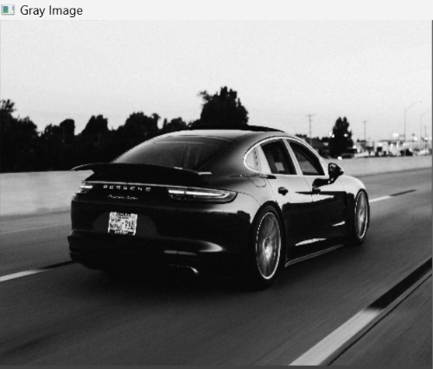
RESULT
Thus, the given image was successfully read using Python OpenCV and converted from a color image to a grayscale image.

